

Project

Interim

Report

On

File

Compression

Simulator

(
Using

Core

Java

&

OOP

Concepts)

RU-100-01-00012

Object

Oriented

Programming

with

Java

SESSION:

2025-26

Submitted

By

Rahul

yadav

RU-25-11075

Bachelor

of

Technology

in

Computer

Science

&

Engineering

in

association

with

Google

Under

the

Guidance

of

Mr.Ashish

Shivhare

SCHOOL

OF

COMPUTER

SCIENCE

AND

ENGINEERING

RUNGTA

INTERNATIONAL

SKILLS

UNIVERSITY

BHILAI,

CG

(
April

2026)

Abstract
The Online Course Management System is a console-based Java application developed to streamline the administration of academic courses and student tracking. In the modern era of e-learning, manual record-keeping is inefficient and prone to errors. This project addresses the need for a lightweight, automated solution that manages data integrity while providing a user-friendly interface for educational tracking.
The system allows administrators to define course parameters (ID, Name, Duration) and manage student profiles. Its core functionality includes a robust enrollment module and a real-time progress tracking feature. By utilizing fundamental Object-Oriented Programming (OOP) principles such as
encapsulation and class interaction, the project ensures a modular and scalable architecture. It effectively bridges the gap between theoretical Java concepts and practical software application, making it an ideal tool for small-scale educational institutes or training centers.

Introduction
This project simulates an e-learning environment where data management is handled through structured objects rather than scattered variables. The primary goal is to maintain a clear relationship between course content and student performance.
Key Features:
- Course Administration: Define and store various subjects with unique identifiers.
- Student Profiling: Maintain unique student records and IDs.
- Interactive Enrollment: Dynamically link students to specific courses.
- Performance Monitoring: Update and retrieve student progress percentages.
Objectives:
- Manage and store course records digitally.
- Track issued courses and student enrollments.
- Reduce manual work by automating data display.
- Apply core OOP concepts like Encapsulation and Association.

Scope
This project is suitable for small libraries or coaching centers. It is currently built for console interaction but is designed to be extensible. Future versions can include database integration (MySQL) for permanent storage and a Graphical User Interface (GUI) using Java Swing.

System Requirements
Hardware: Computer with 4GB RAM
Software: Java JDK, IDE (VS Code/Eclipse/Edit Plus)

Methodology
The development and execution of the system follow a step-by-step logic:
- Initialization: The program starts by creating an array to hold Course and Student
objects.
- Course Creation: Administrator adds course details (Name, ID, Duration).
- Student Registration: Student objects are created with unique IDs.
- Enrollment: The enroll() method is called to associate a student with a specific course.
- Tracking: The user updates progress values (0-100%).
- Reporting: The system iterates through the data to display a final summary report.

Flowchart
FLOWCHART –
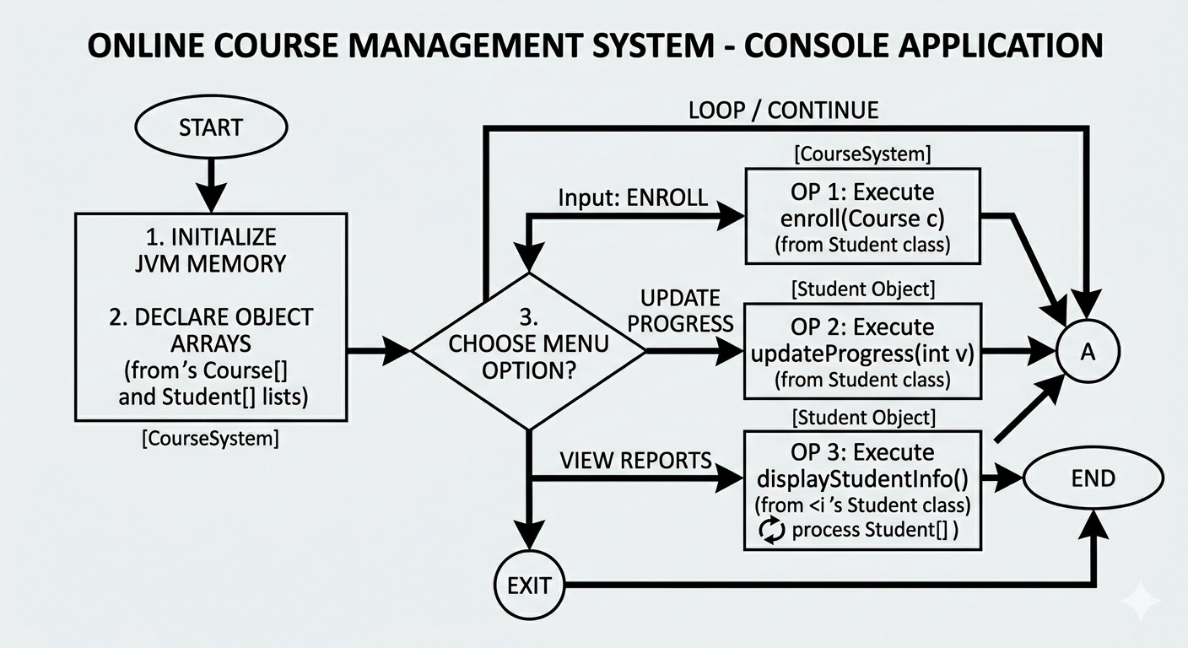
CLASSDIAGRAM –
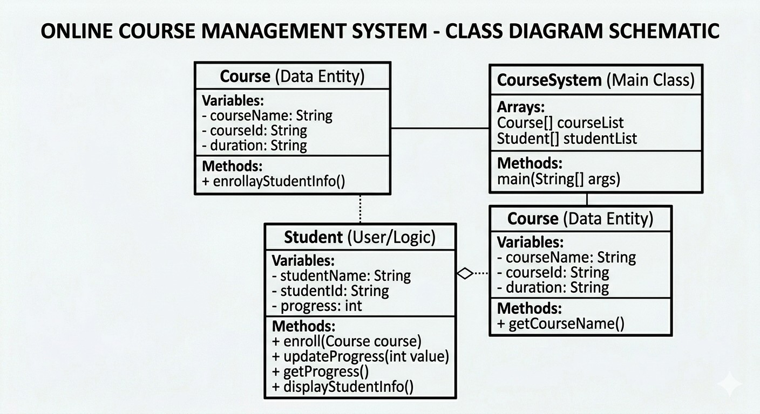

Implementation
In this system, the logic is distributed across three primary classes to maintain a clean separation of concerns, following Object-Oriented Programming (OOP) principles.

1. Course Class
This class acts as a blueprint for the subjects offered.
- Encapsulation: All fields like courseName and courseId are private, accessed via getters and setters.
- Logic: It primarily serves as a data container. It doesn't need to know which students are enrolled; instead, it provides the "identity" of the course that the Student class will reference.

2. Student Class
This is the "active" class where the core logic resides.
- Enrollment Logic: Instead of just a single variable, this class contains an array of Course objects. When the enroll() method is called, it takes a Course object as a parameter and stores it in the next available index of the array.
- Progress Management: It maintains a progress variable (integer). The updateProgress() logic ensures that the value stays within a valid range (0-100) before updating the state.
- Interaction: It demonstrates Aggregation, as a Student "has-a" relationship with Courses.

3. CourseSystem (Main Class)
This acts as the Controller of the application.
- Object Factory: It instantiates the specific courses (e.g., Java, Python) and students.
- Coordination: It triggers the interaction by calling the enroll() method on student objects and passing course objects to them.
- Report Generation: It iterates through the student and course arrays to print the final formatted output, simulating a management dashboard.
Sample Input/Output
Sample Input
Course 1:
Java Programming
C101
3 Months
Sample output
Student Name : Rahul
Student ID : S001
Enrolled Courses:
Java Programming - Progress: 80%
Web Development - Progress: 65%
Terminal Screenshot of code
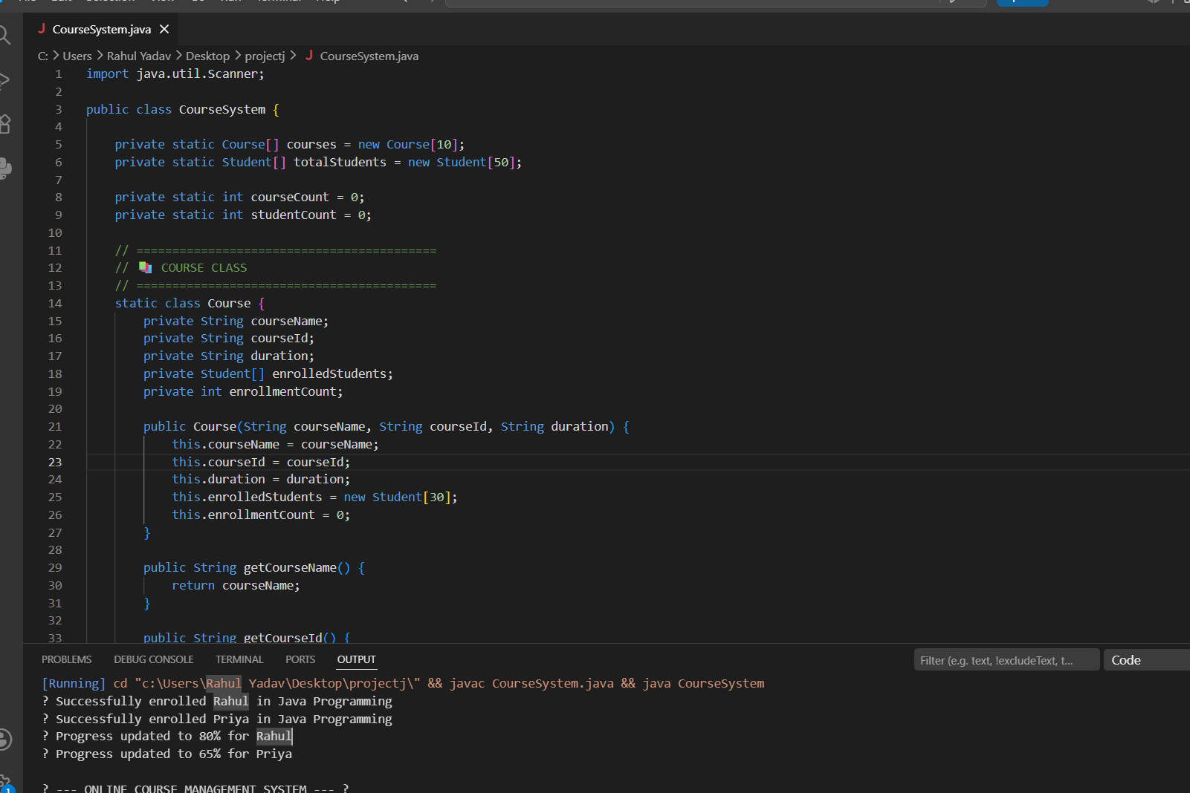

Future Enhancements
To take this project from a "basic" level to an "advanced" level, the following improvements can be implemented:
- Dynamic Data Structures: Replace fixed-size arrays with ArrayList<Student> or
ArrayList<Course>. This allows the system to scale without manually managing array indices or facing ArrayIndexOutOfBounds errors.
- Persistence (File I/O): Currently, data is lost when the program closes. Implementing File Handling (reading/writing to .txt or .csv) would allow the system to save student progress permanently.
- Advanced OOP (Inheritance): Create different types of courses, such as
PracticalCourse and TheoryCourse, inheriting from the base Course class to
handle different grading logic.
- Exception Handling: Add try-catch blocks to handle invalid inputs (e.g., entering text where a progress percentage number is expected) to prevent the program from crashing.
- Menu-Driven Interface: Implement a Scanner based switch-case menu in the main method so users can interactively add students and courses at runtime.
Gantt Chart

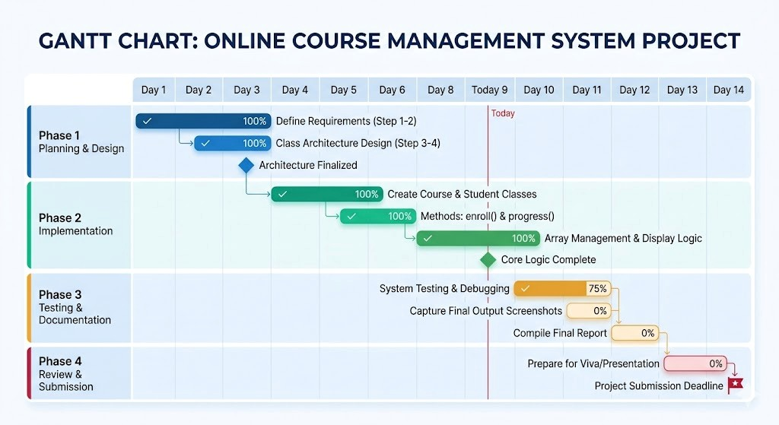

Conclusion

The development of the Library Management System has successfully met its primary objective of automating traditional manual record-keeping. By transitioning from physical registers to a digital platform, the system effectively reduces manual errors, ensures faster data retrieval, and provides a more organized way to track book availability.
From a technical standpoint, the project serves as a practical application of Object-Oriented
Programming (OOP) in Java. Concepts such as Encapsulation (to secure book data), Abstraction (to simplify user interactions), and Array Manipulation (to manage inventory) were central to the system's architecture.
In summary, this project provides a robust foundation for a functional library utility. While currently optimized for small-scale use, its modular design ensures that it is scalable and ready for future upgrades, such as database integration and the addition of a graphical user interface. The system ultimately demonstrates how software logic can be applied to solve everyday organizational challenges efficiently

Reference

To ensure the technical accuracy and structural integrity of this project, the following resources were consulted:

1. Books and Academic Literature
- Schildt, H. (2018). Java: The Complete Reference (11th Edition). McGraw-Hill Education.
Used for implementing core OOP principles and the Collections Framework.
- Deitel, P. J., & Deitel, H. M. (2017). Java How to Program (Late Objects). Pearson. Consulted for designing robust control structures and input validation.

2. Official Documentation
● Oracle Corporation. Java SE Documentation. https://docs.oracle.com/en/java/ Reference for the Scanner class, String methods, and standard API usage.

3. Online Learning Platforms
- GeeksforGeeks. Library Management System in Java. https://www.geeksforgeeks.org/ Used for logic brainstorming regarding array management and searching algorithms.
- W3Schools. Java Tutorial & OOP Concepts. https://www.w3schools.com/java/ Referenced for syntax checking and class structure best practices.

4. Development Tools
● Visual Studio Code Documentation. Java in VS Code.
https://code.visualstudio.com/docs/languages/java
Consulted for setting up the JDK environment and debugging procedures.

